Readme: This project is licensed under the terms of the MIT license.

Video: [C++ 3D Game Tutorial 6: Creating 3D Engine - Drawing a Quad](https://www.youtube.com/watch?v=CElE_sPoFU8&list=PLv8DnRaQOs5-ST_VDqgbbMRtzMtpK36Hy&index=6&t=149s)

Author: Pardcode

**6. Drawing a Quad**

1)

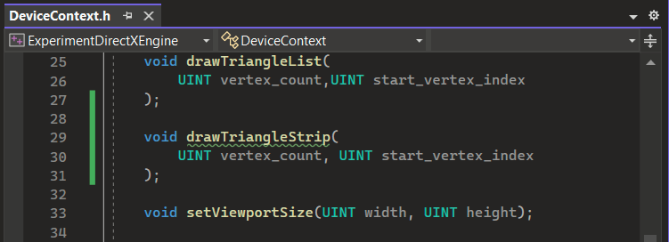

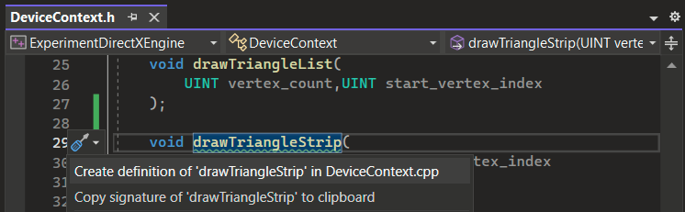

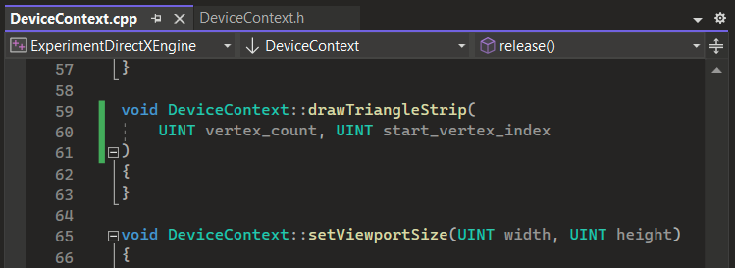

2)

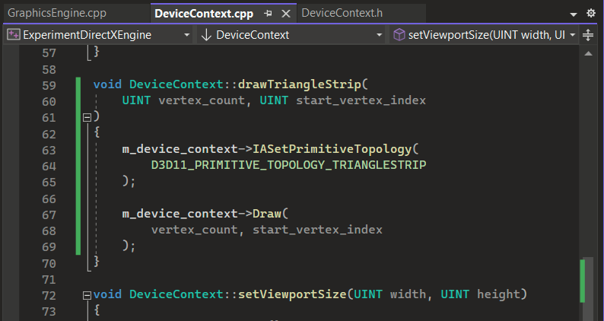

3)

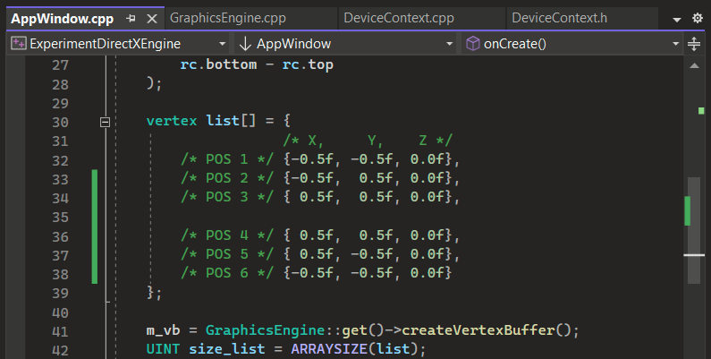

4)

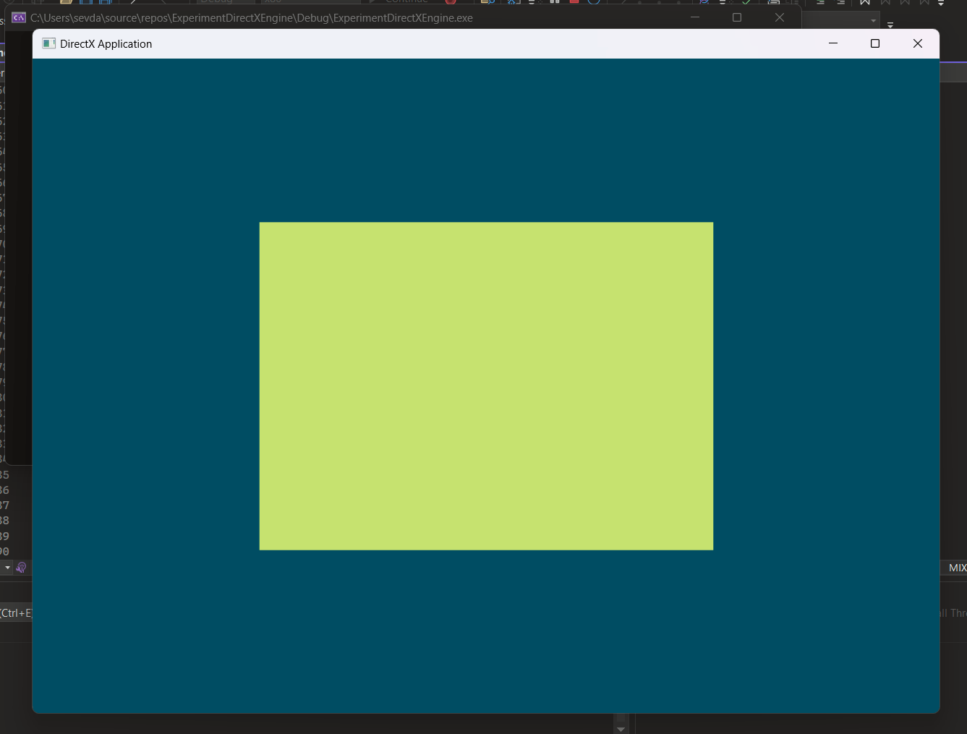

5)

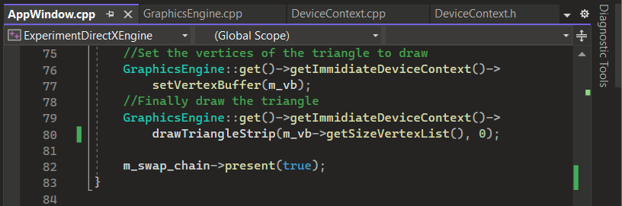

6)

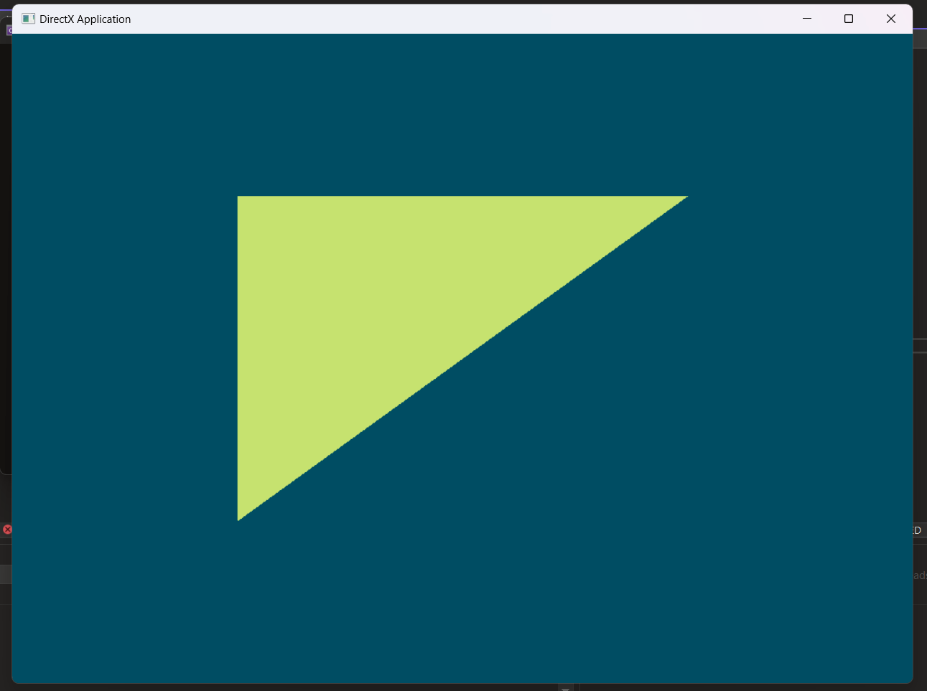

7)

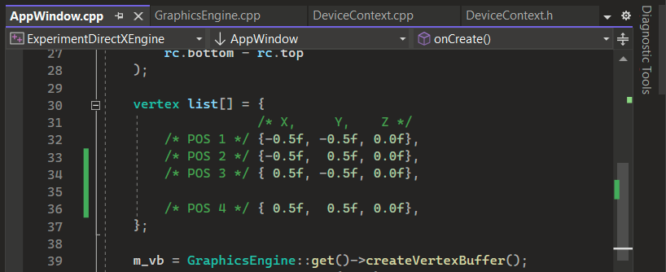

8)

